# Homework 5 – Active Directory and Group Policy Objects

Ryan Foster

CIS 483-01

* (**Task 1**) Show in a screenshot that the three domain users (sqluser1, sqluser2, sqluser3) are created in **SQLUsers** OU. Also show in a screenshot that **sqlgroup** is created in the **Groups** OU.
* A picture containing text, screenshot, monitor, indoor

  Description automatically generated
* (**Task 2**) Go to sqluser1 properties and show in a screenshot that sqluser1 is a member of **Domain Admins** and **sqlgroup**.

* (**Task 3**) Run the following query on SQL Server and show in a screenshot that you indeed logged-on with sqluser1.

* (**Task 4**) Logon to SQL Server. Create a login “**Cardinal1**”. Select **SQL Server authentication**. Enter the password “1234567”, and show in a screenshot that the login cannot be created. Explain why?

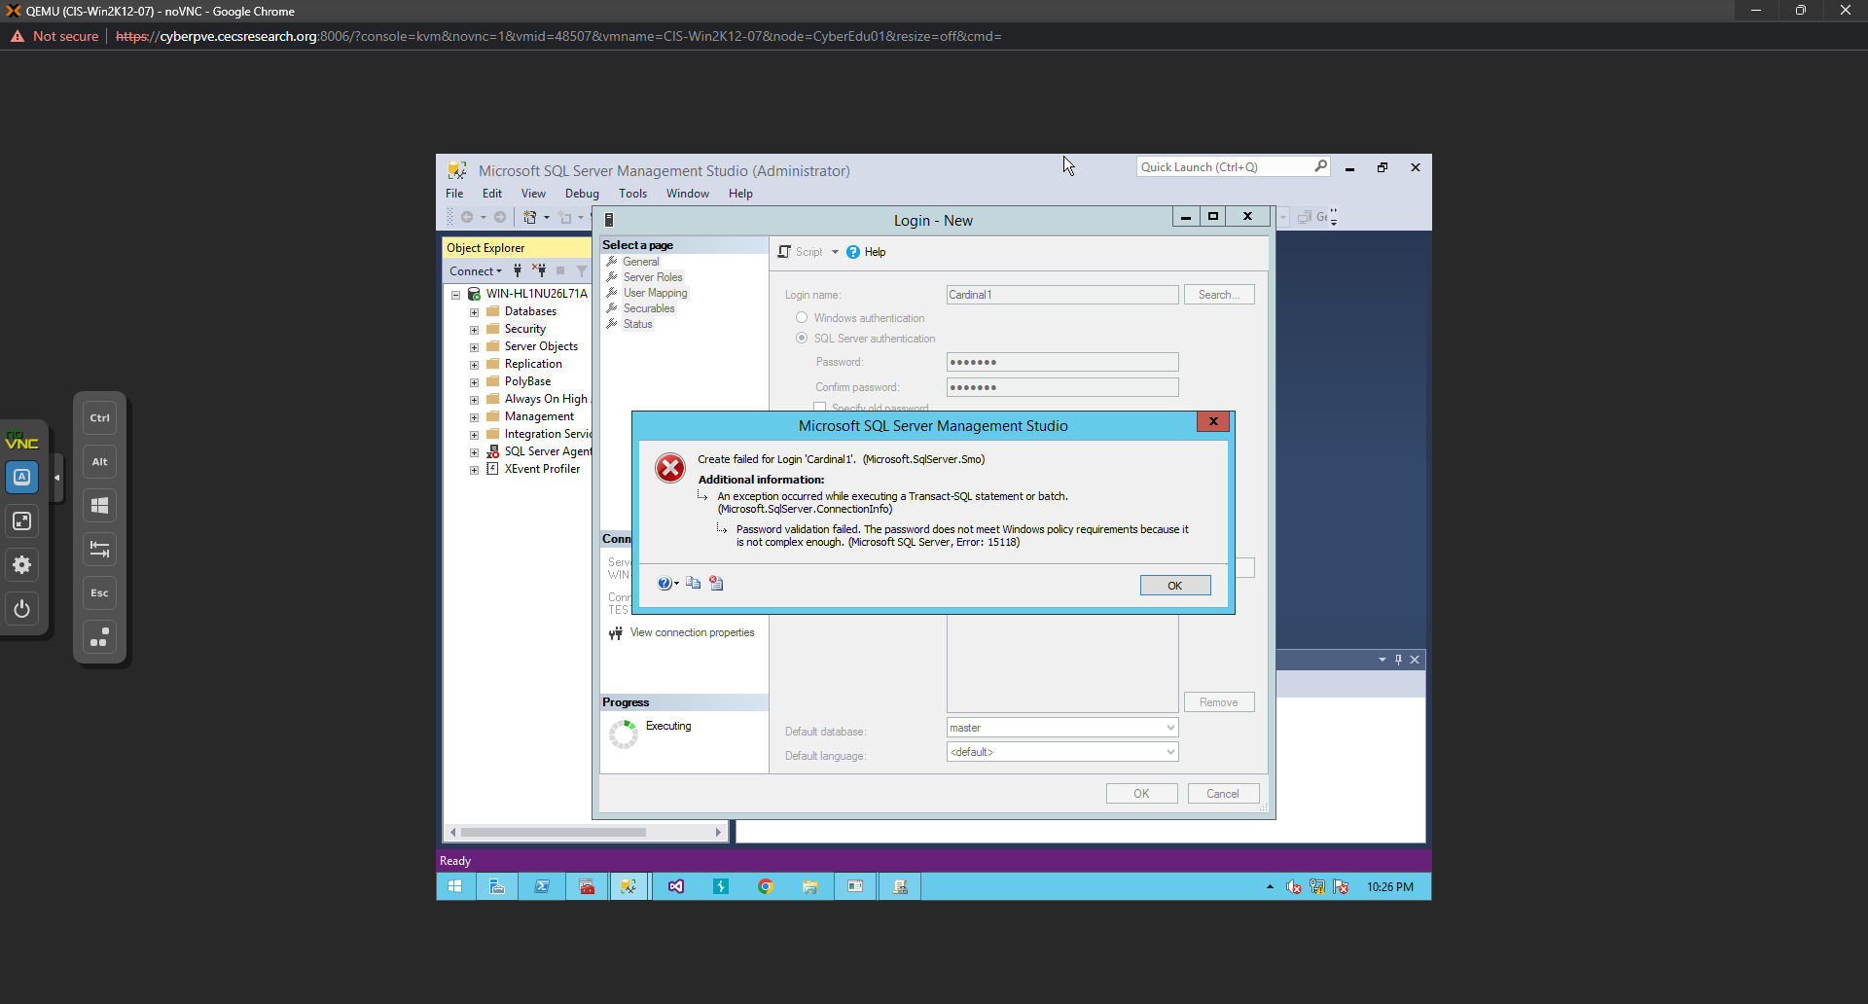

It does not meet the minimum password requirements that were outlined in the group policy, stated that it was not complex enough so the password has to be more complex.

* (**Task 5**) Create a login “**Cardinal1**”. Select **SQL Server authentication**. Enter the password “1234567”, and show in a screenshot that the login is created. Explain why this was possible. Explain also the relationship between the GPO and the SQL Server password policy.

* (**Task 6**) Create a new AD account using the command **New-ADUser** explained on pp 12-13. Show in a screenshot that the account is indeed created (example below). Also, attach a screenshot that displays the PowerShell execution.
* 